CO-1 ASSESSMENT -1

Experiment 8: AI-Based Language Translator
AIM
To develop an AI-based language translator that accepts English text and translates it into a language selected by the user.
INTRODUCTION
Language translation is the process of converting text from one language into another. In this experiment, a Python-based application is developed to accept English text and translate it into languages such as Tamil, Hindi, French, German, and other supported languages. A simple Streamlit interface is used so that the user can enter text, select a language, and view the translated output.
OBJECTIVES
- To accept English text from the user.
- To allow the user to select a target language.
- To translate the entered text automatically.
- To support multiple languages.
- To display the translated text clearly.
- To provide a simple and user-friendly interface.
Code
import streamlit as st
from deep_translator import GoogleTranslator
st.title("🌍 AI-Based Language Translator")
text = st.text_area("Enter English Text:")
languages = {
"Tamil": "ta",
"Hindi": "hi",
"French": "fr",
"German": "de",
"Telugu": "te",
"Malayalam": "ml",
"Spanish": "es",
"Japanese": "ja",
"Korean": "ko",
"Arabic": "ar"
}
language = st.selectbox(
"Select Target Language:",
list(languages.keys())
)

if st.button("Translate"):
if text.strip():
result = GoogleTranslator(
source="en",
target=languages[language]
).translate(text)
st.success("Translated Text:")
st.write(result)

else:
st.warning("Please enter some text.")

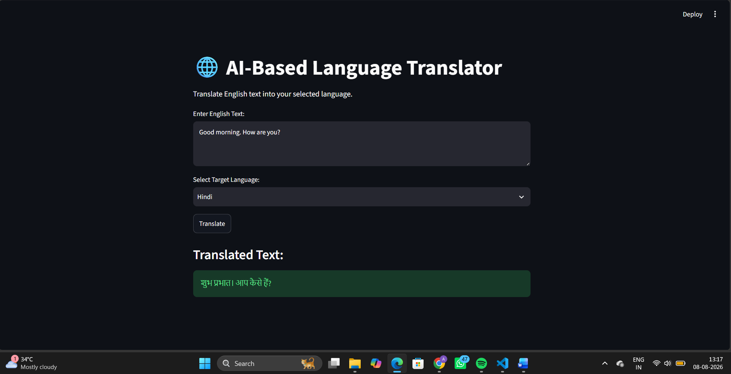

CONCLUSION
The AI-Based Language Translator was successfully developed using Python and Streamlet. The application accepts English text, allows the user to select a target language, and displays the translated text. Thus, the system provides a simple and effective solution for basic multilingual text translation.
Experiment 28: College Regulations RAG Chatbot
AIM
To develop a Retrieval-Augmented Generation (RAG) chatbot that answers user questions using information retrieved from a college regulations PDF.
INTRODUCTION
A RAG chatbot combines document retrieval with generative AI. In this project, a college regulations PDF is used as the knowledge source. The document is divided into smaller sections and converted into embeddings. FAISS is used to find the relevant sections when the user asks a question. The retrieved information is then given to Gemini AI to generate the final answer.
OBJECTIVES
- To read and process a college regulations PDF.
- To extract useful information from the document.
- To create embeddings for the document content.
- To store and search embeddings using FAISS.
- To retrieve relevant information for user questions.
- To generate answers using Gemini AI.
- To avoid answering from information that is not available in the document.
Code
import streamlit as st
from pypdf import PdfReader
from sentence_transformers import SentenceTransformer
import faiss
from google import genai
st.title("College Regulations RAG Chatbot")

# Read PDF
reader = PdfReader("college_regulations.pdf")
text = ""
for page in reader.pages:
text += page.extract_text() + "\n"
# Split text into chunks
words = text.split()
chunks = []
for i in range(0, len(words), 500):
chunks.append(" ".join(words[i:i+500]))
# Create embeddings
model = SentenceTransformer("all-MiniLM-L6-v2")
embeddings = model.encode(chunks)
# Create FAISS index
index = faiss.IndexFlatL2(embeddings.shape[1])
index.add(embeddings)
# Gemini API key
api_key = st.text_input("Enter Gemini API Key", type="password")
# User question
question = st.text_input("Ask your question")
if st.button("Ask Question"):
if api_key and question:
# Convert question into embedding
query_embedding = model.encode([question])
# Find relevant chunks
distances, indices = index.search(query_embedding, 3)
context = "\n\n".join(
chunks[i] for i in indices[0]
)
# Gemini
client = genai.Client(api_key=api_key)
prompt = f"""
Answer the question only using the information
provided in the document.
If the answer is not available in the document,
say that the information is not available.
Document:
{context}
Question:
{question}
"""
response = client.models.generate_content(
model="gemini-3.5-flash",
contents=prompt
)
st.subheader("Answer")
st.write(response.text)
else:
st.warning("Enter API key and question.")

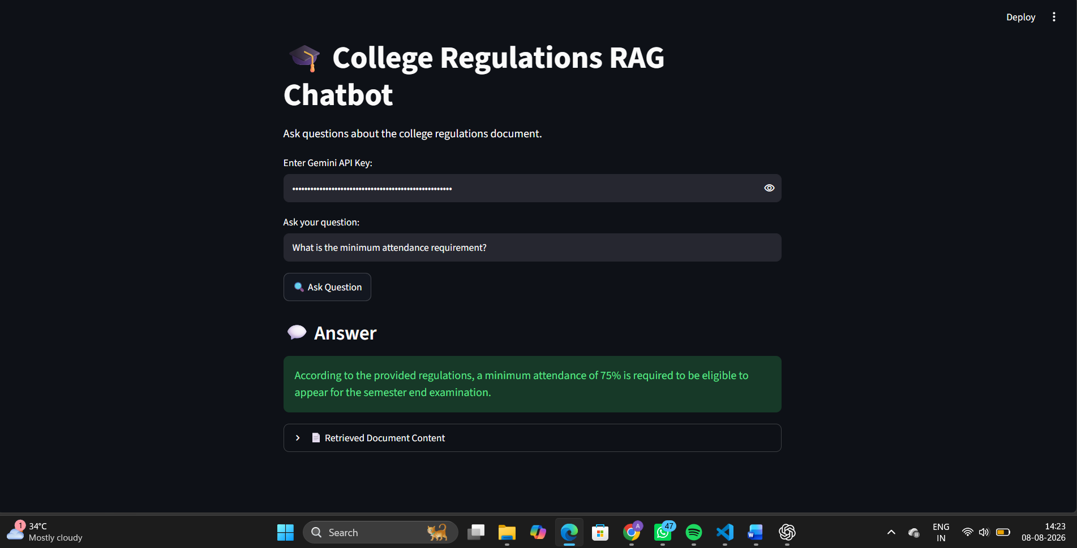
CONCLUSION
The College Regulations RAG Chatbot was successfully developed using Python, Streamlit, PyPDF, Sentence Transformers, FAISS, and Gemini AI. The system retrieves relevant information from the regulations document and uses it to generate answers to user questions. It provides a simple and useful way to search college regulations.

